Ray Fang, Summer 2017, **Development of a Clinically Usable Assessment Tool for Standing Balance**

3 objectives:

1. Obtain the optimal COM or COP parameter to use in assessing standing balance ability that is the most statistically relevant indicator of differences between the three conditions
2. Obtain the optimal location for the placement of a single IMU to approximate body COM
3. Develop a cost-effective assessment tool (in this case, through Wii Board, Shimmer IMU, and Matlab code)

1st objective:

* Compared Prieto’s parameters (see Prieto’s paper in ‘Excel Data’ folder) for COP, as well as COM position RMS, velocity RMS, and acceleration RMS (which form another 3 parameters),
* see ‘prieto_parameters_2trials_average.xlsx’ for the summary of the results, which were obtained from ‘_prieto14x3x56.mat’ file, which was obtained from ‘_prieto14x7x56.mat’ which was obtained from ‘copmeasureAPP.m’,
* manual_plotter creates array of CoM RMS values in the last 3 sheets of the excel file ‘prieto_parameters.xlsx’

2nd objective:

* 3 methods of estimating body COM explained in ‘shimmer_calculations.xlsx’
* ‘heightCalculator.m’ obtains the ASIS, shoulder, COM values for all subjects and outputs an array ’ _height1.mat’ that is used by ‘LinearRegression.m’ for the data found in ‘shimmer_calculations.xlsx’ 1st sheet
* Projection.m creates its own workplace variable (_3DCoMProj.mat) which is used in 2nd sheet of ‘shimmer_calculations.xlsx’ Excel file

3rd objective:

* See ‘WiiShimmerAssessment’ folder section which includes the main matlab script ‘main.m’ to be run with Bluetooth connected Wii Board and Shimmer IMU (more details in that section)

Folders:

* ‘USRP deliverables’ folder
  + Elevator pitch slide, abstract, final poster in pdf and PowerPoint format
* ‘data set notes’ folder
  + notes from the prior experiment that created the data set of 14 subjects to be used, obtained from M-drive
* ‘Data’ folder
  + See the legend at the top (from Angela), cleaned up data from Angela
  + Includes 7 files for 7 trials (2 of EYES OPEN, 2 of EYES CLOSED, 2 of STROOP test, 1 for REST) of **all 14 subjects except for subject 8 which was missing EYES OPEN data (QSEO1 and QSEO2)**
  + Other subject 8 data was not used in the analysis due to the missing data
  + REST trial was not used in the analysis
  + COP data obtained from ‘GCoPx ‘and ‘GCoPy’ in each individual file
  + COM data from ‘CoMx’, ‘CoMy’, ‘CoMz’
  + Since motion capture sampling rate = 200 Hz and there are 14000 points per sample, the first 1000 data points, corresponding to the first 5 seconds, and the last 1000 data points, corresponding to the last 5 seconds were cut for the analysis section to make the trial length 60s from 70s (cuts out error loading on and loading off)
  + Markers data from ‘mdata’
* ‘Excel Data’ folder
  + prieto_parameters.xlsx
    - to calculate all the COP parameters, copmeasures_Ray.m was used for each trial for each condition for each subject
    - 14 subjects x 7 trials x 56 parameters
    - First 4 sheets (COPap, COPml, COPrd, Area) should include these 56 parameters
    - Last 3 sheets (COMx, COMy, COMz) are from the motion capture data, with position, velocity, acceleration RMS parameters
    - These were found from simply differentiating (data was filtered already by Angela) the CoMx CoMy and CoMz data, and cutting the first and last 5 seconds of the trial, as mentioned above in the ‘Data folder’
    - Str3 column is the rest data
    - Subject 1: Str3 COM data was missing
    - Note that subject 8 row is cleared of contents because data was missing

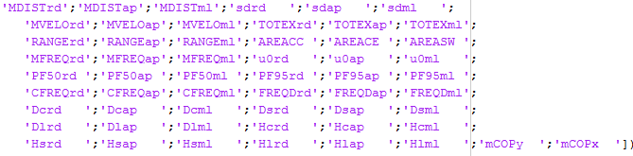

Figure 1. List of the parameters calculated by copmeasures_Ray.m in order (output is 56 length vector), **for explanations of parameters and acronyms, see the included Prieto paper in ‘Excel Data’ folder**

* + prieto_parameters_2trials_average.xlsx
    - same as above, except there are 3 columns for the 3 conditions (eyes closed, eyes open, stroop test)
    - each column is the average of the two trials for that condition
    - on the bottom are the results of the t-test
    - first row = paired t-test between EYES CLOSED and EYES OPEN
    - second row = paired t-test between EYES CLOSED and STROOP TEST
    - third row = paired t-test between EYES OPEN and STROOP test
    - yellow highlight for when p < 0.05, blue highlight for when p < 0.167
  + shimmer_calculations.xlsx
    - see final poster for explanation
    - method 1 (multiple regression to approximate COM) outlined in first sheet (CoMz), uses ASIS and Shoulder marker data as independent variables
    - formula of the regression equation in the cells of the regression estimate column, using Shoulder and ASIS data columns
    - sheet #2 (Method 2, 3), results outlined in poster, method 2 results (finding location as the trunk ratio) at the bottom of the Trunk Ratio column (10% of the trunk above the ASIS) , where trunk ratio is d1/d2

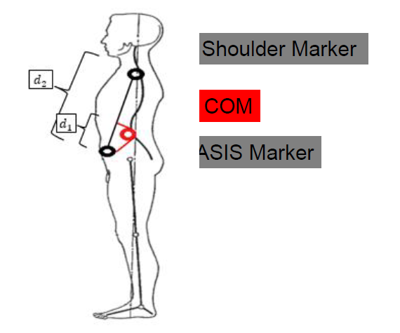

Fig.2

* + - method 3 (finding IMU location as the flat distance from COM to ASIS) results at the bottom of the first column of each trial (about 50 mm or 5 cm above the ASIS)
    - first column is equal to the magnitude of the (COM-ASIS) vector projected onto the (shoulder-ASIS) vector
* ‘MATLAB’ folder
  + Includes matlab scripts, functions, files
  + copmeasures_Ray.m
    - see Fig.1, function used to calculate parameters
    - more detailed documentation is found commented into the code
    - uses GCoPx and GCoPy as inputs (global COP, left and right)
  + _prieto14x7x56_cut.mat
    - Mat file of the data found in prieto_parameters.xlsx, see above and Fig.1 for the order, e.g. array(: , : , 2) corresponds to ‘MDISTap’ parameter (mean distance in the AP direction) for all subjects and all conditions
    - ‘cut’ refers to the first 5 seconds and last 5 seconds of the 70s trial being removed from analysis
    - For the force plate, since Fs = 1000 Hz, the first 5000 data points and last 5000 points are removed, more information is found inside the copmeasures_Ray.m code which was applied to every condition for every subject (**note that the data in place of subject 8 is all 0**)
  + _prieto14x3x56_cut.mat
    - Same as above but for the averaged data found in prieto_parameters_2trials_average.xlsx
  + copmeasureAPP.m
    - applies copmeasures_Ray.m to every trial matfile and obtains the array ‘_prieto14x7x56_cut.mat’
  + _height1.mat
    - 14 subjects by rows
    - Column 1-3= eyes open trial 1 {COMZ, Shoulder Height, ASIS height}
    - Column 4-6 = eyes open trial 2{COMZ, Shoulder Height, ASIS height}
    - Data obtained from each file’s ‘mdata’ struct
    - Data in ‘shimmer_calculations.xlsx file sheet #1
  + heightCalculator.m
    - creates the ‘_height1.mat’ array from matfile mdata structs
  + linearRegression.m
    - finds the regression coefficients
    - takes in _height1.mat as input
    - output ‘b’ first column are coefficients for first trial
    - second column are coefficients for second trial
    - COM = c1 + c2 * shoulder + c3 * asis + c4 * shoulder * asis
  + Projection.m
    - See above in ‘shimmer_calculations.xlsx file sheet #2
    - Calculates 14 subjects x 4 array data for the methods 2 and 3 used on the second sheet of the excel file
    - Columns 1-2= eyes open trial 1{ COM-ASIS (proj) , shoulder-ASIS}
    - Columns 3-4= eyes open trial 2{ COM-ASIS (proj), shoulder-ASIS}
    - Data in ‘shimmer_calculations.xlsx file sheet #2
    - COM-ASIS (proj) column is equal to the magnitude of the (COM-ASIS) vector projected onto the (shoulder-ASIS) vector
  + _3DCoMProj.mat
    - Data from Projection.m saved as matlab workplace variable
  + differentiate.m
    - differentiate function by Kei
  + manual_plotter.m
    - creates 14 subject x 7 trial x 3 parameter (COM pos, COM vel, COM acc) RMS values for x, y, or z direction (change in line 33), cuts data points to 60s
* ‘WiiShimmer Assessment’ folder
  + There is a ‘realterm’ executable to install the ‘realterm’ software from Shimmer which is required to read data from the Shimmer IMU
  + WiiLab folder
    - I used a publically available library for Wii, “WiiLab”
    - This is the library used for interfacing the Wii Balance Board with Matlab (<http://netscale.cse.nd.edu/twiki/bin/view/Edu/WiiMote>)
    - **IMPORTANT: copy paste this folder into your Program Files folder (not Program Files x86) in your (probably) C: drive**
    - **Open it in your Program Files folder, run ‘InstallWiiLab.bat’ as administrator to install WiiLab**
  + CU_Wii folder (kept the name of the folder)
    - built on top of the CU-Wii Project GUI, credit goes to them
    - http://www.colorado.edu/intphys/neuromechanics/cu_wii.html
    - main.m
      * main script, run this after connecting Balance Board and Shimmer IMU to computer’s Bluetooth
      * This will prompt for Shimmer comport if you selected to use Shimmer, you only need to input the number of the comport the IMU is connected to
      * Comport number can be found on Windows 10 after connecting the Shimmer through Bluetooth by going to Bluetooth settings - > more Bluetooth options -> comport tab -> whichever comport number is listed as ‘outgoing’ to Shimmer
      * Calibrating the Wii Board: follow the instructions on screen slowly
    - copmeasures_use.m
      * similar to copmeasures_Ray.m used earlier for the analysis
      * modified to just calculate the parameters needed for the analysis of Wii Board data
    - SetEnabledSensorsMacrosClass.m
      * Code from Shimmer API required to run the Shimmer
    - ShimmerHandleClass.m
      * Code from Shimmer API required to run the Shimmer
    - ‘WiiBBFunctions’ folder
      * Mostly buttons for the GUI and miscellaneous matlab functions for the program
    - ‘Data’ folder
      * Recorded data from the program are recorded here in txt format according to the time they were recorded
      * These txt files can be opened in excel
      * Contains a ‘realtermBuffer’ folder which is used to store the arriving data from the Shimmer which is then read by the program

**NOTE: The calibration settings are stored in the individual Shimmer IMUs. To change the calibration settings, you have to download the Shimmer 9DoF Calibration software from the Shimmer website to calibrate it.**